# **Opportunity to Join Residency of International Writers as Literary Ambassadors for Wales**

## [Literature Wales](https://www.literaturewales.org/) is inviting applications from Welsh authors to join international writers on a two-week creative writing residency at Tŷ Newydd Writing Centre between **17 and 31 May 2025**.

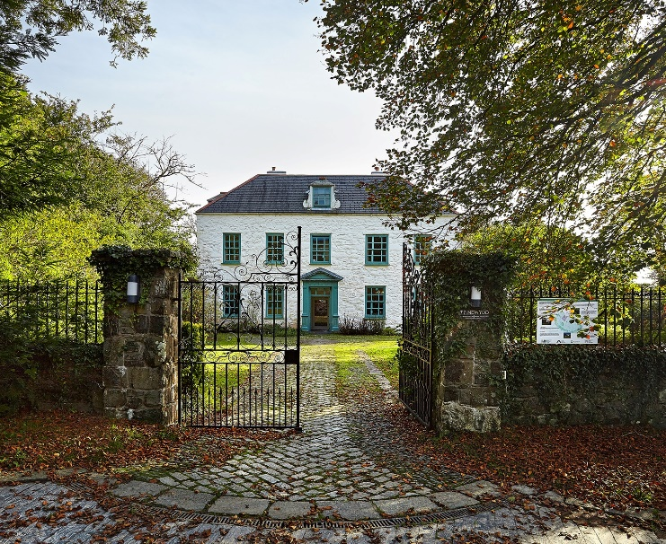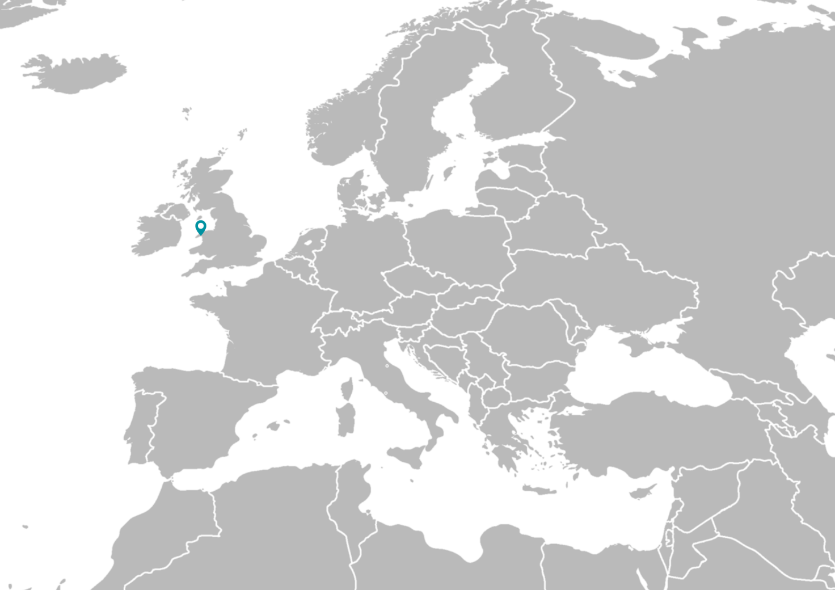

For a fortnight in May 2025, Tŷ Newydd will home 14 European writers, who will collaborate creatively on projects around the themes of ecology, the climate emergency, society and people. All 14 writers will work in a minoritised language, and will work together to explore languages, landscape and communities.

Nine writers will be selected from Europe, and five from Wales.

The writers will receive accommodation and home cooked meals provided by the resident chef on site at Tŷ Newydd Writing Centre, and all travel costs will be covered in addition to relevant expenses[1]. There will be opportunities to receive paid work as a facilitator during the fortnight to deliver a session with the group and/or to take part in a celebratory and sharing event in Hay Festival.

## What you will receive:

* Time and space to write in the peaceful setting of Tŷ Newydd
* A stimulating creative programme of workshops, talks, walks and discussions to develop your knowledge and career as a writer
* Connections with like-minded writers from across Europe, and expanded knowledge and understanding of how language and landscape are interlinked
* Opportunity to represent Wales and exchange information about our values, culture, literature and systems
* Networking with European cultural institutes and producing partners who are interested in working with Welsh writers
* Visit to Hay Festival, and possible inclusion in an event showcasing the residency.

## Writers’ Eligibility Criteria

* Writers must be over the age of 18
* Writers must write in Welsh or another minoritised language or must have a particular interest or knowledge in the topic of minoritised languages.
* Writers must be available to reside at Tŷ Newydd Writing Centre from 18-31 May 2025.
* This opportunity is for established or mid-career creative writers who practice poetry, prose, or creative non-fiction. We expect the writer to have published a book or contributed towards an anthology or a publication on the theme of ecology, landscape, the climate emergency, people or society. We will also consider applications from established literary facilitators working in communities on the same topics. This is it not an opportunity aimed towards writers of academic work or texts.

## Outputs

We won’t expect or request set outputs by the end of the residency. The aim is to offer writers the opportunity to write, reflect and build an international creative community. This will hopefully lead to the creation of several radical creative international collaborations in endangered languages and the sharing of solutions and ideas across Europe. Celebratory events offering an opportunity to share creative work and learning will be organised as part of the retreat at [Hay Festival](https://www.hayfestival.com/hay-on-wye/home).

## How to Apply

Fill out [this SurveyMonkey Application Form](https://www.surveymonkey.com/r/TTKJR3G), or you can [download an accessible version here.](https://www.literaturewales.org/wp-content/uploads/2024/10/EUNIC-Application-Form-Dyslexia-Friendly.docx)

Literature Wales is responsible for assessing all applications.

The deadline to apply is **midday on Friday 15 November 2024**.

For further information about the residency, or for an informal chat before applying, please contact [post@literaturewales.org](mailto:post@literaturewales.org) with EUNIC in the subject box.

Literature Wales will notify all writers (successful and unsuccessful) of the outcome by 1 February 2025.

## Appendix: Further Information

**Context**

Languages reflect the values, traditions, and beliefs of a culture. They are a tool for communication and vehicles for thought, expression, art, and literature. Each one offers a unique perspective on the world and reflects the range of human experience and learning rooted in a particular place. Never has language’s connection to landscape been more evident as within the current unfolding context of the climate emergency. If nothing is done, conservative estimates suggest that half of all the 7,000 languages currently spoken will be extinct by the end of the century. With them, the knowledge, culture and crucially, solutions they carry will be lost.

Across the globe, many small linguistic communities have been pushed to coastlines which are now vulnerable to hurricanes and sea level rise. Others live on lands where rising temperatures threaten traditional farming and fishing practices, prompting migration. Alongside this increase in forced migration, the extinction of biodiversity and the erosion of landscapes, also heavily contribute to the impoverishment of vocabulary within communal memory.

Similarly to life forms across the globe however, languages have also learnt to adapt and evolve- sometimes thriving against the odds and in the most unexpected of places. This is cause for celebration and collaboration, as different communities across the globe set out to increase awareness of the interconnection between landscape and language and the challenges and opportunities this poses.

**Further reading:**

[European Charter for Regional and Minority Languages](https://rm.coe.int/november-2022-revised-table-languages-covered-english-/1680a8fef4)

[Lost for words: fears of ‘catastrophic’ language loss due to rising seas | Climate crisis | The Guardian](https://www.theguardian.com/environment/2023/jan/16/linguists-language-culture-loss-end-of-century-sea-levels-rise)

[A decade to prevent the disappearance of 3,000 languages – UNESCO-IESALC](https://www.iesalc.unesco.org/en/2022/02/21/a-decade-to-prevent-the-disappearance-of-3000-languages/)

**The retreat**

With each writer representing a particular culture and their relationship to the language(s) and landscape of their community, we’d be looking to invite established or mid-career writers who have already written on the theme and are able to be creative ambassadors for their country/ region. Each of the 14 selected writer’s work will explore their culture’s unique ties to nature, ecology and/or society through a range of forms and genres.

During the residency, a focused programme of talks, group workshops and facilitated group discussions will be curated for the participants. These sessions will be led mainly by climate specialists and artists who will in their turn share their own research and creative practice. Participants will be encouraged to address and explore key concepts such as climate justice, nature, and language development alongside our relationship with time, wild and urban spaces, and other-than-human species. All the while, participants will have the opportunity to explore the local area on organised field trips, learning about the biodiversity of Llŷn and Eifionydd, as well as the social and economic dynamics found in a seaside area with a high percentage of Welsh-speakers. Each of the 14 writers will also be invited beforehand to lead a talk, a discussion or a workshop with the group to share the context surrounding the linguistic and ecological landscape of their country/region, as well as presenting their creative work as a way of encouraging exchange, collaboration and partnering.

The residency will culminate in a sharing event at Hay Festival 2025. More information about this element will follow soon. All accommodation and travel arrangements to Hay will be organised by Literature Wales.

As a way of ensuring legacy to the project, writers taking part will be encouraged to incorporate learning acquired during the residency into their work and share ideas developed during the two weeks within their networks back home.

**Tŷ Newydd Writing Centre**

Run by Literature Wales, the national organisation responsible for developing writers in Wales, Tŷ Newydd has run as a Writing Centre since 1990. Every year, courses are run in a variety of genres and on different themes and topics, and tutors at the centre have included world-renowned writers including Gillian Clarke, Carol Ann Duffy, Manon Steffan Ros, Benjamin Zephaniah, Menna Elfyn, Jackie Kay, Gwyneth Lewis and Louis de Bernières.

The house was built in the 15th century. Tŷ Newydd was the last home of the former Prime Minister David Lloyd George who died at the house in 1954. The centre is in Llanystumdwy in Gwynedd, between the sea and mountains. 74.4% of the local population in Llanystumdwy speak Welsh.

**Accommodation and Catering**

During the two-week residency, each writer will have their own bedroom on site at Tŷ Newydd Writing Centre. Catering will be provided by the resident chef, who will be able to cater around allergies or dietary requirements. Further information about the visit to Hay Festival will be shared closer to the time.

For information about accessibility at the centre, visit [Tŷ Newydd’s website](https://tynewydd.wales/the-house/access/) or [contact us](https://tynewydd.wales/contact/) to discuss your access needs.

**Travelling to/from the centre**

Literature Wales staff, in partnership with EUNIC, will assist all 14 writers with their travel arrangements to, and from the centre. In keeping with the residency’s priorities, green and sustainable travel to and from the centre will be encouraged and supported by the partners. Travel costs will be reimbursed or paid for by the organisers on the writers’ behalf.

**Further questions**

If you need any further information about this opportunity, please contact [post@literaturewales.org](mailto:post@literaturewales.org) with EUNIC in the subject title.

1. Terms and Conditions apply, and green and sustainable travel to and from the centre will be encouraged and supported by the partners.