How to create your own publication: A guide

This guide offers some questions and ideas about what to consider when setting up a publication. There will be some practical considerations, as well as some more creative and personal considerations. When starting a publication, you may well have the same question as I did: Where do I begin? Nothing we decide is ever truly set in stone, unless stone tablets are your format of choice. Assuming this is not the case, then this is the time to be ambitious. What do you really want to create? How do you want it to feel? How do you want to interact with it? And what will that look like? In other words, what kind of publication do you want to create?

What kind of publication do you want to create?
- Digital (website)
- Digital (PDF/downloadable)
- Print
- Other

Each publication type has benefits. A digital website-style publication is probably the least costly in terms of setting up, depending on your goals. When we started Lucent Dreaming, we used a free WordPress website to share submission guidelines and our email address. We also set up social media accounts, also for free, and away we went. As we were the sort of the publication looking for unsolicited submissions (that is, work we didn’t commission ourselves), we also got in touch with two website databases who list magazines (also known as ‘markets’) to gain a wider reach in terms of submissions received. These two websites are The Submission Grinder and Duotrope. There are many others including Chill Subs and plenty of Facebook groups where you can list your publications or advertise open call submissions.
PDF and print publications likely require the same kind of software investment. You can use packages like Adobe InDesign or Canva to create PDF/downloadable publications. Downloadable publications can be found via websites or social media, or other holding pages. Google and Mailchimp, for example, offer website-style holding pages.

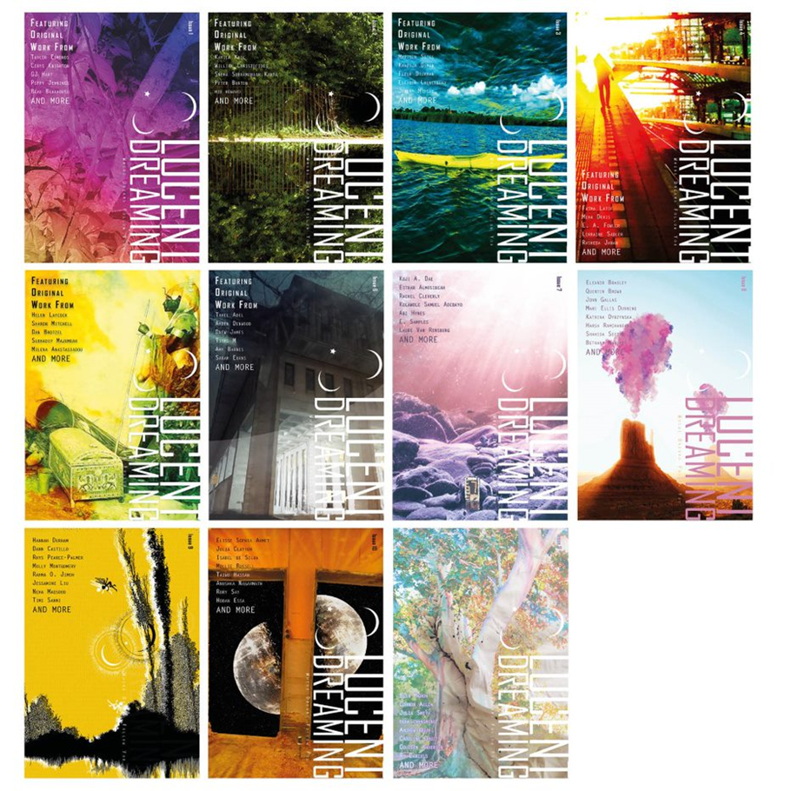

Print publication
If you are looking to go into print publication, you’ll want to learn the basics of a typesetting and design software. You can use Adobe InDesign to create print-ready PDFs. There are lots of tutorials online. Some things to consider when setting up any kind of PDF or print document is to understand some of the principles of design. I recommend looking at a lot of books to build your own template. Notice the width of the margins, the size of the font, the style, the spacing, the contrast. Some people have a better eye for design than others, so if you’re able to do so, it is worth investing in having design support. Books Council of Wales offer a subsidised design service which is worth taking advantage of if you have the literature, but not the design know-how (and the time to learn).
Once you are ready to go to print, you should find a printer who aligns with your own ethics. This may mean that you wish to use local printers only, to support your local independent businesses, or nation-wide printers who offers competitive rates if you’re looking to print, produce and/or sell to make a profit. We use Mixam for our magazines and 4edge for our short-run books. Mixam has a really useful instantaneous quote system on its website so you can play around with paper quality and type, cover finishes, and quantity to see at a glance how much a print run may cost.

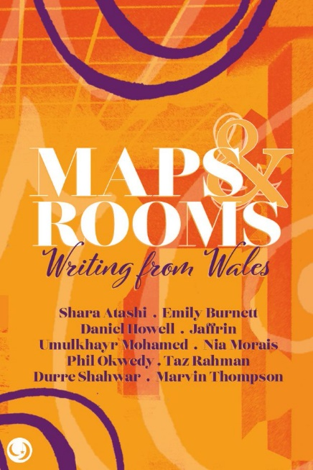

Legal obligations
If you are going into print publication, other things to be aware of are legal obligations should you begin to operate as a business selling books and magazines. There are six Legal Deposit libraries in the UK, and you are legally required to deposit one copy of your printed publication to The British Library, and retain another five copies in case the other libraries request them. You may also wish to look into insurance such as Public Liability and Professional Indemnity to safeguard your work. We use Hiscox. You should also look at how you will complete your accounting and if you are operating as a self-employed freelancer, or as a business.
If you’re beginning a magazine or other serial journal or publication, you can request a free ISSN (International Standard Serial Number) for your publication from The British Library. For books, you will most likely purchase ISBNs (International Standard Book Number) from Nielsen’s ISBN Store, and request an account with Nielsen Title Editor to list information about your books for the trade and booksellers. In order to do request a Title Editor account, you need to state who your distributor will be. We use Books Council of Wales’s distribution service. There are others such as Coresource by Ingram, Gardners, and Hachette UK Distribution.

Practical considerations
I’ve briefly mentioned some of the practical considerations for setting up as a publisher. You should be aware of your own strengths and limitations in order to know how to address them. Ask yourself which of these resources you have and which you may not:
- time
- energy
- friends and networks
- ideas
- money
- motivation
- passion
- technology/software
- equipment
Once you have identified these, are there ways you can fill the gaps that you see might be necessary for setting up your publication? I was fortunate that I had many of these resources when beginning, excepting money (which did affect access to technology and software and time/energy). However, after receiving some unexpected seed funding of £750 from a graduate scheme, I was able to invest in an Adobe subscription and cover the cost of the first print run of the magazine as well as other costs. The first two years, the magazine was paid for by the editors, including myself, as we had other paid work, but since 2019, we have received around £1100 to £1700 in grants per issue of our magazine from Books Council of Wales (BCW) through their Small Magazines and Press Grant. BCW grants have been transformative for us and enabled us to start paying contributors. Similar funding for books and magazines is also available through Arts Council England.

Do you know your mission?
Now, you may have a name for your publication, but do you know why you want to create this publication specifically? Do you know your mission?
There are a few recurring missions I’ve identified in my own creative pursuits: to create something better than already exists; to create my own version of something; to create something I think is missing, i.e., to fill a gap; to create something for fun; and to create for another purpose, e.g., charitable reasons. Once you identify which of these is your mission for your publication, you can research and uncover further questions to ask yourself. Say you want to fill a gap, look at ways in which other niche publications have filled a gap. Is there any other work that’s been done before that can serve as a template? Is there anyone you can talk to about that?

Values and ambitions
Last but certainly not least, identifying your values and ambitions. One of the most grounding things you can do for any piece of artwork, for any publication, is to identify what values you hold and the values and ambitions you have for the project. We used Nesta’s The Creative Enterprise Toolkit to help support this work. The five most important values that we identified from completing the toolkit, and still hold true today are: aesthetics; growth; helping others; work/life balance and creativity. Every decision we now make, or ambition we have for our publication, we can judge against these values.
If you have further questions about the content of this resource, you can contact Jannat Ahmed whose details are available at LucentDreaming.com
Hyperlinks
Reference and Website hyperlink
The Submission Grinder
Duotrope
Adobe InDesign
Canva
Google
Mailchimp
Books Council of Wales
Mixam
4edge
The British Library, and legal deposit
Legal Deposit Libraries
Hiscox
ISSN (International Standard Serial Number)
ISBNs (International Standard Book Number)
Nielsen’s ISBN Store
Books Council of Wales Distribution Service
Books Council of Wales grants
Coresource by Ingram
Gardners
Hachette UK Distribution
NESTA: The Creative Enterprise Toolkit
Lucent Dreaming

*Literature Wales is not responsible for information/resources provided by third parties.

Resource content by Jannat Ahmed

